2021 VIRTUAL
THE 16TH ASIAN SOCIETY FOR CLINICAL PATHOLOGIST
AND LABORATORY MEDICINE CONGRESS

16th January 2021

CONGRESS REPORT

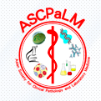

Hosted by Indonesian Association of Clinical Pathologist and Laboratory Medicine (IACPaLM)

BACKGROUND
The COVID-19 pandemic has been going on for about 1 year, causing pressure on all aspects of life in all countries, especially in the health sector. All countries are taking action against the COVID-19 pandemic to minimize casualties and prevent further spread. Clinical Pathologist (CP) is a profession that stands at the forefront of this "war" and plays a significant role in screening, diagnosis, monitoring and surveillance. This profession also involves in the determination of the laboratory method and clinical pathway, not only at the hospital and laboratory levels but in national level decision making as well.
Covid19 is a new disease that is very complex, causing many obstacles to laboratory services, as well as creating challenges that must be faced by CP collectively, unite and cooperate. Therefore, “Unite for Combatting COVID-19” was appointed as the 16th ASCPaLM Congress theme.
The 16th ASCPaLM Congress was supposed to be held in September 2020, but because it was still in a pandemic situation, it will then be held on January 16th 2021. The aim of this meeting is for knowledge and experience sharing among country members of the society on COVID situation, strategy, and obstacles, as well as sharing about clinical pathologist education in pandemic situation.

CONGRESS THEME
Unite for Combatting COVID-19: Challenges in The Field of Clinical Pathology

DATE, TIME, AND PLATFORM OF THE MEETING
January 16th 2021
08.00-15.00 Jakarta Time
Zoom

COMMITTEE
STEERING COMMITTEE
Prof Hayato Miyachi, MD (President of ASCPaLM)
Prof Po Ren Hsueh, MD, PhD (Secretary General of ASCPaLM)
Prof DR dr Aryati, MS, SpPK-M (President of IACPaLM)
Dr Marina Ludong, SpPK (Secretary General of IACPaLM)
Dr Sri Hartini, SpPK (Vice President of IACPaLM)
Presidents of ASCPaLM Member Societies

ORGANIZING COMMITTEE
Chairperson : DR dr Teguh Triyono, SpPK(K) :
Secretary : dr Weny Rinawati, SpPK(K), MARS
dr Izzuki Miftah, SpPK
Treasurer : dr Betty Tambunan, SpPK(K)
Dr Cut Alamanda, SpPK
Dr Nisayu Dewi, SpPK(K)
Scientific : dr Lidya Utami, SpPK(K)
Publication and technical : dr MI Diah, SpPK(K)
dr Prafa Alif Rahmawan
dr Yosua Butar butar
Event : dr Dwita Riadini
dr Cynthia Ayu Permatasari
dr Ihda Kartika Syamsuddin
dr Yustisia Amalia
dr Renata Permatasari (MC)
dr Binar Larasanti Savitri (MC)
Secretary office : dr Dewintha Airene Novianti
dr Widya Firly Novitasari
dr Priskila Christy
dr Febriani Puspitasari
dr NFH Melida Ritonga

PARTICIPANTS
Members of Society and residents from all member state
Registration status: free, by registering at 16th ASCPaLM website : www.ascpalm16.org
Attending participants :
Total 1248, consisted of:
- Indonesia : 1111
- Japan : 30
- Taiwan : 13
- Mongolia : 3
- Korea : 1
- Malaysia : 2
- China : 1

AGENDA
- Presentation 1: The Roles of Clinical Pathologists in COVID-19 Pandemic
Topics: COVID recent situation, laboratory services strategy, methods implemented, local/hospital/national policy, obstacles, specific role of clinical pathologist
Presented by each member society, @20 min.
- Presentation 2: Adaptations for Residential Program During COVID-19 Pandemic
Topics: Challenges and strategy for residential program in COVID-19 pandemic, how to minimize risk, replace deficiencies, involvement in combatting COVID-19
Presented by each member society, @20 min.
- Video presentation: Company profile @10 min
- Executive Board and Council Meeting of ASCPaLM (90 min)

CONGRESS RUNDOWN
Time  (Jakarta time) | Activities
07.45-08.00 | Opening video
08.00-08.10 | Welcome Speech: President of IACPaLM  Prof. Dr.dr Aryati, dr, MS, SpPK (K)
08.10-08.20 | Opening Speech: President of ASCPaLM  Prof. Hayato Miyachi, MD, PhD
08.20-08.40 | Company profile video-1 (Indonesia & Japan)
SYMPOSIUM-1
Moderator: Prof. Masahiro Koshiba, MD, PhD (Japan)
Co-moderator: Prof. Enkhsaikhan Lkhagvasuren, MD, PhD (Mongolia)
08.40-09.00 | The Roles of Clinical Pathologists in combatting COVID-19: Presentation from Japan  Prof. Hayato Miyachi, MD, PhD  Tokai University School of Medicine
09.00-09.20 | The Roles of Clinical Pathologists in combatting COVID-19: Presentation from Korea  Prof. Kiho Hong, MD, PhD  Yonsei University College of Medicine, Severance Hospital
09.20-09.40 | The Roles of Clinical Pathologists in combatting COVID-19: Presentation from Taiwan  Prof. Hung-Sheng Shang, MD, PhD  Tri Service General Hospital Taipei
09.40-10.00 | The Roles of Clinical Pathologists in combatting COVID-19: Presentation from Mongolia  Prof. Enkhsaikhan Lkhagvasuren, MD, PhD  Mongolian National University of Medical Sciences
10.00-10.20 | The Roles of Clinical Pathologists in combatting COVID-19: Presentation from Indonesia  Prof. Dr. Aryati, dr. MS, SpPK(K)  University of Airlangga
10.20-10.40 | Discussion
10.40-11.10 | Break
SYMPOSIUM-2
Moderator: Prof. Sang Hoon Song, MD, PhD (Korea)
Co-moderator: Prof Po-Ren Hsueh, MD, PhD (Taiwan)
11.10-11.30 | Adaptations for Residential Program during COVID 19 pandemic: Presentation from Japan  Prof Tatsuo Shimosawa, MD, PhD  International University of Health and Welfare, Chiba
11.30-11.50 | Adaptations for Residential Program during COVID 19 pandemic: Presentation from Korea  Prof. Dae-Hyun KOH, MD, PhD  Asan Medical Center
11.50-12.10 | Adaptations for Residential Program during COVID 19 pandemic: Presentation from Taiwan  Kuei-Pin Chung, MD, PhD  National Taiwan University Hospital
12.10-12.30 | Adaptations for Residential Program during COVID 19 pandemic: Presentation from Mongolia  Prof. Khosbayar Tulgaa, MD, PhD  Mongolian National University of Medical Sciences
12.30-12.50 | Adaptations for Residential Program during COVID 19 pandemic: Presentation from Indonesia  Prof Dr dr Ida Parwati, SpPK(K)  University of Padjajaran
12.50-13.10 | Discussion
13.10-13.40 | Company profile video-2 (Korea, Mongolia and Taiwan)
13.40-13.50 | Closing session and Break
13.50-14.20 | Executive Board Meeting
14.20-14.30 | Break
14.30-15.20 | Executive Board and Council Meeting

SPEAKERS AND MODERATORS
Speakers and moderators are from country members, nominated by each society.
Curriculum vitaes are as follows

SYMPOSIUM 1: THE ROLES OF CLINICAL PATHOLOGISTS IN COVID-19 PANDEMIC

MODERATOR OF SYMPOSIUM 1:

- Prof Masahiro Koshiba, MD, PhD – JAPAN

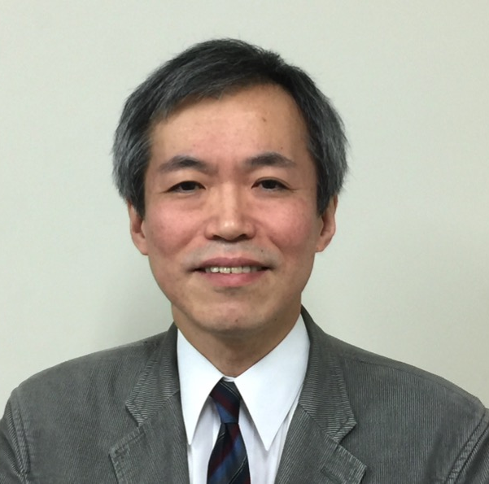

Current Position
- Chief Professor and Chairman, Department of Clinical Laboratory Medicine, Hyogo College of Medicine, Japan
- Director, Department of Clinical Laboratory, Hyogo College of Medicine Hospital, Japan
- Japanese Society of Laboratory Medicine (Board-Certified; Director-at-Large [2014-Date]; Councilor of the Society; Chairperson of the 63rd National Congress 2016)
- Japan Society of Clinical Chemistry (Councilor of the Society;
Education
  - Faculty of Medicine, Kyoto University, Japan, MD (1984)
  - Graduate School of Medicine, Kyoto University, Japan, PhD (1993)

(2) Prof Enkhsaikhan Lkhagvasuren, MD, PhD - MONGOLIA
Current position
Associate professor, Department of Immunology, School of Biomedicine, Mongolian National University of Medical Sciences
Education
- Bachelor of Science Degree, Health Sciences University of Mongolia, (2003)
- Master of Science Degree, Health Sciences University of Mongolia (2005)
- Residence course of Internal Medicine, Health Sciences University of Mongolia (2009)
- Doctor of Philosophy, Tokushima University Japan (2013)

SPEAKERS OF SYMPOSIUM 1
- Prof Hayato Miyachi – JAPAN

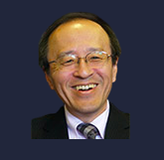
Current position
- Director/Chief, Clinical Laboratory and Laboratory Medicine, Tokai University Hospital, Isehara
- Professor, Laboratory Medicine, Tokai University School of Medicine
- President, Asian Society for Clinical Pathology and Laboratory Medicine
- President, College of Laboratory Medicine of Japan
- Secretary General, Japanese Society of Laboratory Medicine
- Board of directors, Japanese Committee for Clinical Laboratory and Standard, Japanese Society of Laboratory Hematology, Japan Society of Gene Diagnosis and Therapy
Education
- Keio University School of Medicine, with M.D. degree Post-graduate (1981)
- Clinical and Research Fellow, Internal Medicine (Department of Hematology), Keio University School of Medicine, Tokyo, Japan
- Visiting Scientist, City of Hope National Medical Center, Duarte, CA, USA

- Prof Kiho Hong MD PhD - KOREA
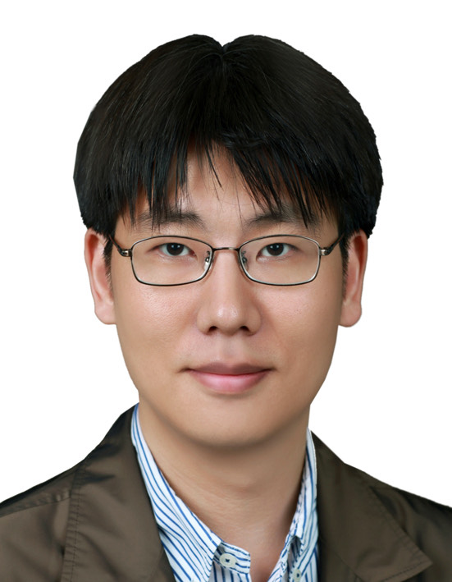
Current position
- Clinical Professor, Department of Laboratory Medicine, Yonsei University College of Medicine, Severance Hospital 2021.1~
- Director, Department of Laboratory Medicine, Seoul Medical Center 2012-2020
- Secretary, COVID-19 Taskforce, Korean Society for Laboratory Medicine (2020.1.~ present)
Education
- Seoul National University M.D. (2004)
- Seoul National University Ph.D. (2016)

(3) Prof Hung-Sheng Shang, MD, PhD - TAIWAN
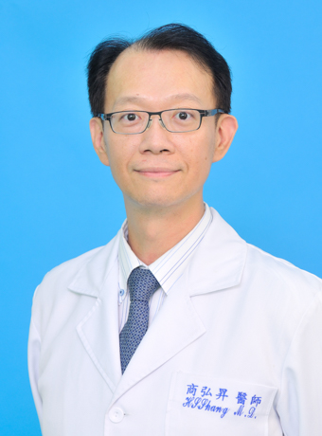
Current position
- Laboratory Director, Division of Clinical Pathology, Tri-Service General Hospital Taipei
Education
- National Defense Medical Center, Taiwan M.D. (2003 )
- Graduate institute of clinical medicine, Taipei medical university PH.D (2018 )

(4) Prof Enkhsaikhan Lkhagvasuren, MD, PhD - MONGOLIA
As mentioned above
(5) Prof. Dr Aryati, dr, MS, SpPK-K - INDONESIA
- 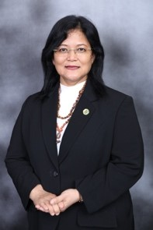
Current position:
- Professor and head of subspecialist program of Clincal Pathology, Faculty of Medicine, Airlangga University, Surabaya
- President of Indonesian Association of Clinical pathologist and Laboratory Medicine, 2019-2022
- Member of Expert Panel, Indonesian COVID-19 Taskforce
Education
- Faculty of Medicine, Airlangga University, MD (1988)
- Faculty of Medicine, Airlangga University, Magister of Immunology (1992)
- Faculty of Medicine, Airlangga University, Clinical Pathology (2000)
- Faculty of Medicine, Airlangga University, PhD (2006)

SYMPOSIUM 2 : ADAPTATIONS FOR RESIDENTIAL PROGRAM DURING COVID-19 PANDEMIC
MODERATORS OF SYMPOSIUM 2
- Prof Sang Hoon Song, MD, PhD., JAPAN
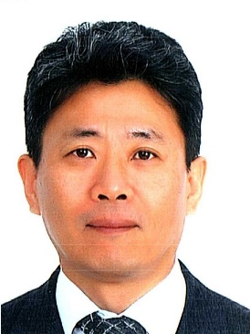

Current Position
- Associate Professor, Seoul National University Hospital
- Secretary General, Korean Society for Laboratory Medicine (KSLM)
- IFCC Affairs, Korean Society of Clinical Chemistry (KSCC)
Education
- Seoul National University : MD, residency, master degree, fellowship, PhD

- Prof Po-Ren Hsueh- TAIWAN

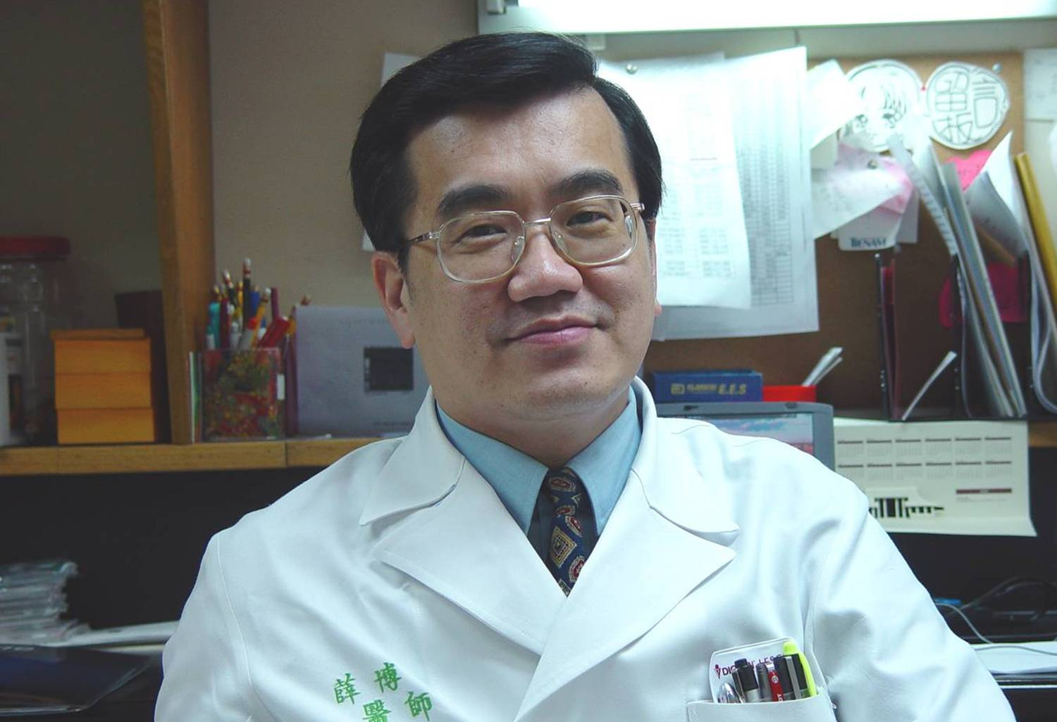

Current position
- Professor, Departments of Laboratory Medicine and Internal Medicine at the National Taiwan University College of Medicine (NTUCM)
- President of Taiwan Society of Microbiology (TSM) and Taiwan Society of Clinical Pathology and Laboratory Medicine (TSCPaLM)
- Secretary-general of Asian Society of Clinical Pathology and Laboratory Medicine (ASCPaLM)
- Executive Committee Member of the Infectious Diseases Society of Taiwan (IDST)

SPEAKERS OF SYMPOSIUM 2
(1)Prof Tatsuo Shimosawa, MD, PhD – JAPAN

- 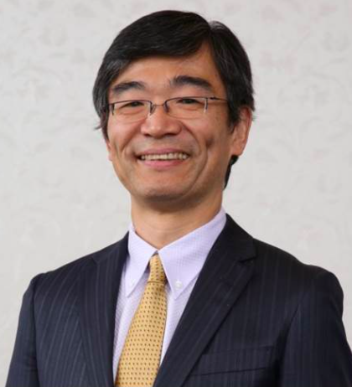
Current Position
- Professor and Chairperson, Department of Clinical Laboratory, Graduate School of Medicine, International University of Health and Welfare, Chiba
- Visiting Professor, Hebei University of Chinese Medicine, Hebei, China
- Director of Japanese Society of Hypertension
- Director of Japanese Society of Caridovascular Endocrinology and Metabolism
Education
- Tsukuba University School of Medicine, Ibaraki, Japan : MD (1988)
- Tokyo University : PhD (1997)

- Dae-Hyun Ko, MD, PhD – KOREA
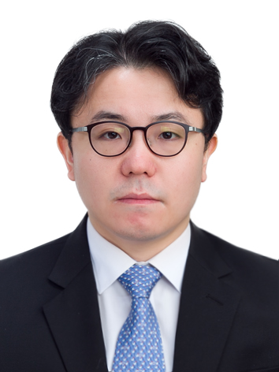
Current Position
  - Assistant Professor, Department of Laboratory Medicine (Clinical Pathology) Asan Medical Center
  - Director of Public Relations, Korean Society of Blood Transfusion
  - Director of General Affairs, Korean Society for Patient Blood Management
  - Director of Publications, Korean Society for Genetic Diagnosis
Education
- Pre-Medical School, Seoul National University, Seoul, Korea (2002)
- M.D. College of Medicine, Seoul National University (SNU) (2006)
- M.Sc. (Laboratory Medicine) Graduate School, SNU (2011)
- Ph.D. (Laboratory Medicine) Graduate School, SNU (2020)

- Kuei-Pin Chung, MD, PhD -TAIWAN
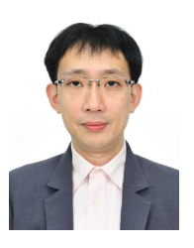
Current Position
- Attending physician, Department of Laboratory Medicine, National Taiwan University Hospital and National Taiwan University Cancer Center
- Secretary-general, Taiwan Society of Clinical Pathology and Laboratory Medicine
Education
- College of Medicine, National Taiwan University : MD (2003)
- Graduate Institute of Clinical Medicine, College of Medicine, National Taiwan University : PhD (2019)

- Prof Khosbayar Tulgaa -MONGOLIA

Current Position
- Associate Professor, Senior Lecturer Department of Clinical Laboratory, Mongolian National University of Medical Sciences
- Master trainer on COVID – 19 laboratory testing MOH, WHO, UNICEF, UNFPA: COVID-19 infection prevention, control and clinical management
- Master trainer on Tuberculosis :ADB TA 9438-MON: Improving the Screening Program for Viral Hepatitis in Mongolia (extension).
Education
- Postdoc Avison International Fellowship (AIF), Yonsei University, Seoul, Korea
- Ph.D in Molecular Biology, Health Sciences University of Mongolia, Ulaanbaatar, Mongolia
- M.Sc in Microbiology, Health Sciences University of Mongolia, Ulaanbaatar, Mongolia
- Clinical Pathologist, Health Sciences University of Mongolia, Ulaanbaatar, Mongolia
- Bachelor of Science, Medical doctor, Medical University of Mongolia, Ulaanbaatar, Mongolia

- Prof Dr dr Ida Parwati, SpPK(K), PhD - INDONESIA

- 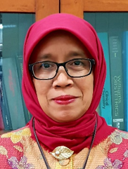

Current Position
- Professor in Clinical Pathology, Universitas Padjadjaran
- Chairman of Indonesian Clinical Pathology College (2019-2023)
Education
- Medical doctor, University of Padjadjaran (1982)
- Clinical Pathologist, University of Padjadjaran (1992)
- Doctor/S3,, University of Padjadjaran (2004)
- Consultant of Tropical and Infectious Disease/Clinical
- Microbiology (2007)
- PhD, Radboud University Medical Center Nijmegen - The Netherlands(2009)

ASSIGNMENT | SESSION | NAME | COUNTRY | CONTACT
Moderator | 1 | Masahiro Koshiba | Japan | mkoshiba@hyo-med.ac.jp
Co-moderator | 1 | L Enkshaikhan | Mongolia | enkhsaikhan@mnums.edu.mn
Moderator | 2 | Sang Hoon SONG | Korea | cloak21@snu.ac.kr
Co-moderator | 2 | Po-Ren Hsueh | Taiwan | hsporen@ntu.edu.tw
Speaker | 1 | Hayato Miyachi | Japan | miyachi@is.icc.u-tokai.ac.jp
Speaker | 1 | Ki Ho HONG | Korea | kihohongmd@gmail.com
Speaker | 1 | Hung-Sheng Shang | Taiwan | iamkeith001@gmail.com
Speaker | 1 | L Enkshaikhan | Mongolia | enkhsaikhan@mnums.edu.mn
Speaker | 1 | Aryati | Indonesia | dr_aryati@yahoo.com
Speaker | 2 | Tatsuo Shimosawa | Japan | tshimo-tky@umin.ac.jp
Speaker | 2 | Dae-Hyun Ko | Korea | daehyuni1118@gmail.com
Speaker | 2 | Kuei-Pin Chung | Taiwan | gbchung@ntu.edu.tw
Speaker | 2 | T Khosbayar | Mongolia | khosbayar.t@mnums.edu.mn
Speaker | 2 | Ida Parwati | Indonesia | idaparwati2008@gmail.com

EXPENSES
In Indonesian rupiah (IDR)
1 | Meeting room | 2,500,000
2 | Drinking water | 31,500
3 | Video rental | 1,500,000
4 | Zoom | 10,000,000
5 | Website | 1,589,500
 | Total | 15,621,000

APPENDIX
- CONGRESS FLYER
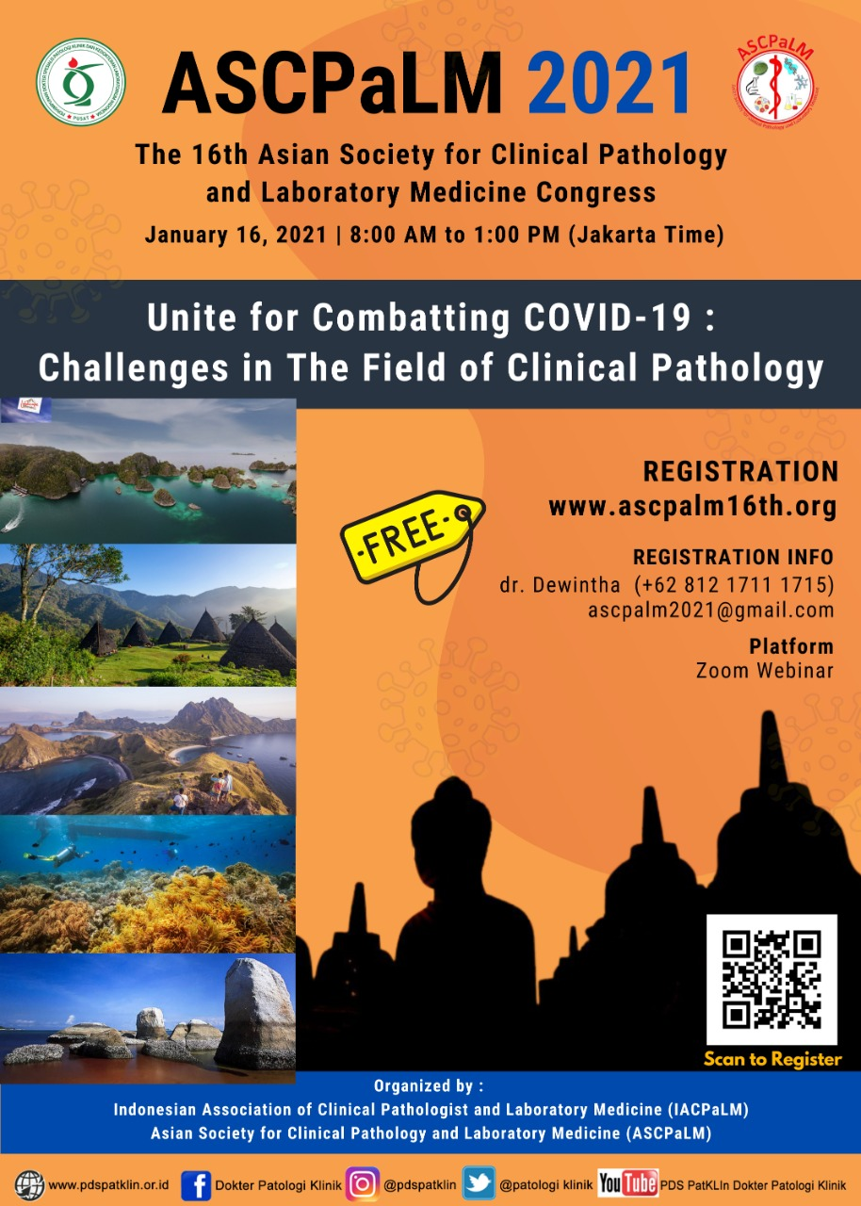

- VIRTUAL BACKGROUND
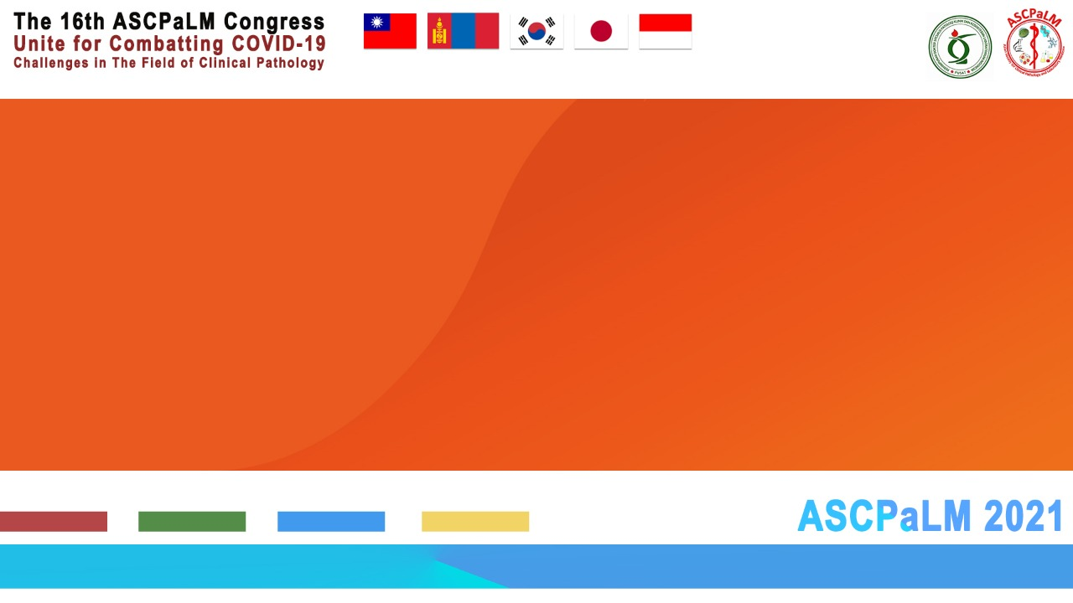
3.CERTIFICATE

